BIODIVERSITY
for
BALLYOISIN

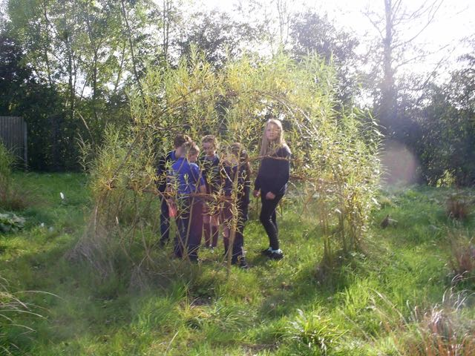
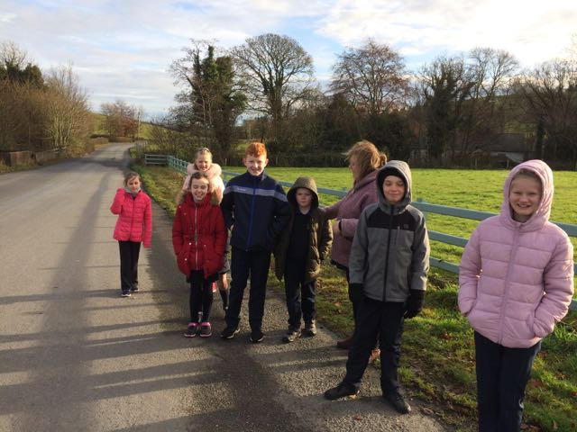

A LOCAL BIODIVERSITY ACTION PLAN FOR BALLYOISIN, KNOCKCONAN, CO. MONAGHAN

Prepared by the Green School Committee of Knockconan National School, Miss Emer Brennan, School Principal and Billy Flynn of Flynn Furney Environmental Consultants.

Emer, want to put in a funding acknowledgement here or anything?

INTRODUCTION

This is a plan for wildlife-friendly enhancement and management of the grounds of Knockconan National School and Ballyoisín. This plan has been made by the Knockconan National School Green School Committee. It is for the school and all the residents of Ballyoisín. It was written after two visits to the school and the village by an ecologist who was shown around by the Green School Committee and Miss Brennan. It has ideas and suggestions for ways to make the school grounds and the village better for wildlife and nicer to look at too!

IDEAS FROM THE GREEN SCHOOL COMMITTEE

Before we had any visits or surveys, the Green School Committee came up with a list of ideas of things they might like to see included in the plan. These were:

- Trees | - A Sensory Garden
- Wildflowers | - Flowers around the Pitch
- Bird Feeders | - Variety
- Flowers on Path | - Fix the Insect Hotel
- A Bee Hotel | - Lupins
- Low-Mow (the grass) at Oisín Vale | - Crocuses
- Bricks with Holes | - Records for the NBDC

OUR VISIT AND SURVEY

On 2nd December 2019, an Ecologist visited the school. We talked about our ideas and then we had a site visit at the school and to the village. We carried out a survey on the visit. We looked at areas that could be improved and made better for wildlife.
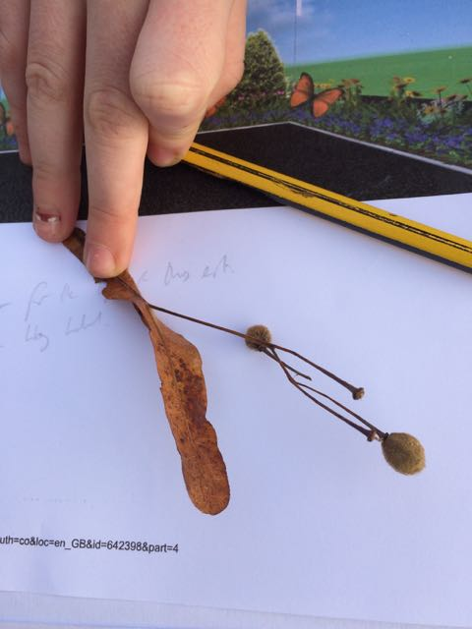

We looked at the grassy play areas to the west of the school, a Willow dome, a bug hotel, some grassy verges, the proposed site of the new church, the grounds of the old church (now closed) and the large grassy slope between the school and the church.

We also visited Oisín Brian housing estate and the Oisín Vale estate, looking at the trees, hedgerows and boundaries on the way there.

THE BALLYOISIN BIODIVERSITY PLAN

These are the biodiversity projects we would like to have in our plan.

WHAT | WHERE
Project 1: Mini Woodland | South-west Corner of School Grounds
This would be the establishment of a small native woodland that would be of great benefit for birds. We propose planting Birch, Sessile Oak and Holly. We will need to source native trees and also put tree guards around the young trees while they are growing. We could plant up to 30 trees here.

WHEN | You can plant broadleaved trees between October and March.

WHAT | WHERE
2. Low-Mow Area | At Entrance to School
We propose that a grassy area on the way into the school becomes a low-mow area. We propose that the grass here is only cut once per year, in the autumn. It is important that the cuttings are removed after this. This management will have the effect of reducing soil fertility and allow native wildflowers (that may already be here) to germinate. We will check each year on how many different species can be found here. | 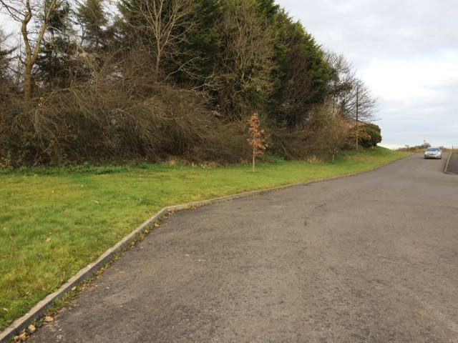
WHEN | Grass will be cut in September and cuttings removed

WHAT | WHERE
3. Pollinator-friendly Bulbs | On the Grass Strip at the Flagpoles
At the moment, this is just grass  We propose to plant a mixture of pollinator-friendly bulbs here. These will include Aliums and Agapanthus. These are expensive so we might only plant a strip (about a metre wide) around the flagpoles, leaving room for people to put up and take down our flags as they need to. | 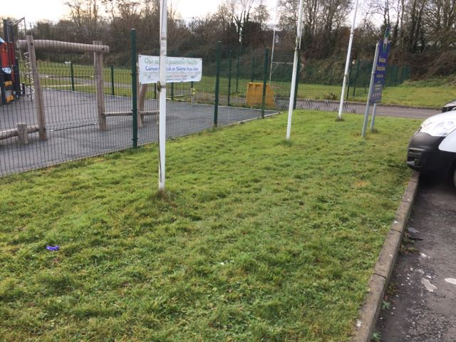
WHEN | Bulbs will be planted in Winter

WHAT | WHERE
4. Spring Bulbs | Along the Basketball Court Fencing
This area could be really brightened up by planting dozens of bulbs of flowers like the colourful Crocus. These are of benefit to early pollinators like Bumblebees. We could also plant some small bug-friendly plants that flower later, like Potentilla. | 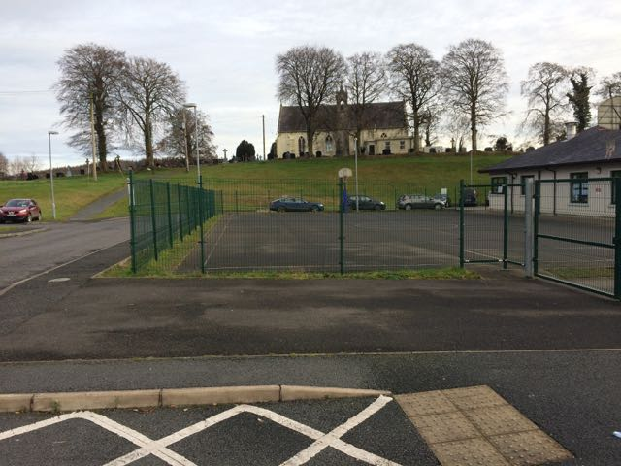
WHEN | Bulbs will be planted in Winter and Potentilla can be planted in the Spring.

WHAT | WHERE
5. A Bee Bank | On Slope of New Church Site
Not all bees live in hives. Many live as single male and female bees. We call these solitary bees. Solitary bees nest in tiny burrows that they make in bare soil or in cavities like holes in wood or hollow stems. They emerge from hibernation in spring and make a nest in narrow places. They prefer south-facing banks so this slope is perfect. All we need to do is keep an area of bank clear of vegetation. We can report any bee sightings to the National Biodiversity Data Centre. | 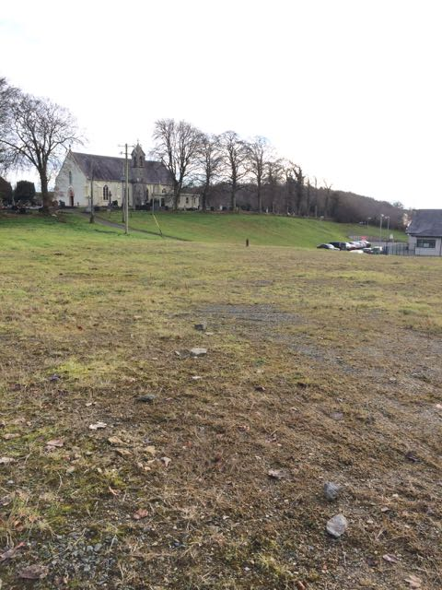
WHEN | We can clear plants in the autumn and start maintaining our Bee Bank when work at the church is finished.

WHAT | WHERE
6. Wildflower Path | Along the Path to the Old Church
We propose to create a Wildflower Meadow that will extend all the way along the path between the school and the old church. This will be a perennial wildflower meadow on both sides of the path. We will prepare the ground by removing grass and some of the soil layer. We will then sow a seed mixture of wildflowers that are suited to this area. We will then have to manage the area every year. | 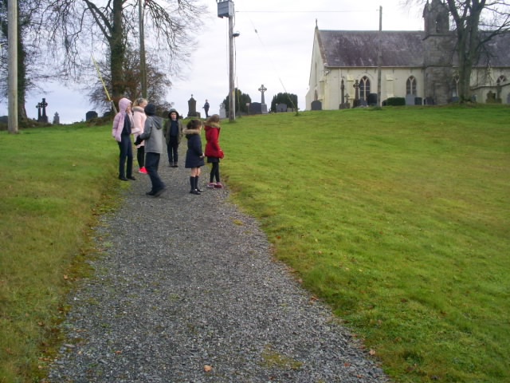
WHEN | We can sow in either autumn or spring. We can prepare the ground before this. We will need to keep the meadow cut quite short during the first year. On other years we will cut this only once (in October or November).

WHAT | WHERE
7. Low-Mow Strip | On Eastern Side of School
This will be another strip of grass that is only cut once per year. It will gradually develop flowers and it will act as a wildlife-corridor along the length of the school. We can also plant some bulbs such as Crocus and Lupins in this for more colour. | 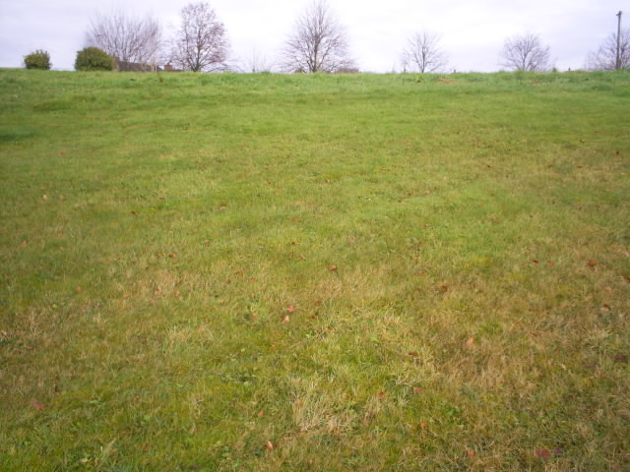
WHEN | Grass will be cut in September and cuttings removed

WHAT | WHERE
8. Fruit Trees | On Eastern Side of School
We will buy some locally-grown apple trees of a variety that is common in Co. Monaghan and Armagh. We will plant these in an even line (about 10m apart) just behind our Low-Mow Strip (Project 7). These will form a really good corridor for Bumblebees but birds will also benefit from these trees. | 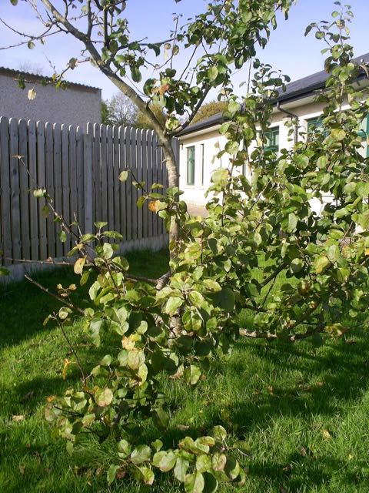
WHEN | We can plant the Apple Trees between October and March.

WHAT | WHERE
9. New Woodland | On the Large Green between the School and Church
We propose to replace an area of the large green between the school and the church with a new woodland. This should be made up of native broadleaved species like Oak, Hazel, Rowan and Alder but we can also include Scots Pine and Larch. We could get help with the costs of this planting by making this a Neighbourwood Project. We can plant the trees at around 2-3m spacing. We will have to put in stakes and tree guards to keep them safe and straight. | 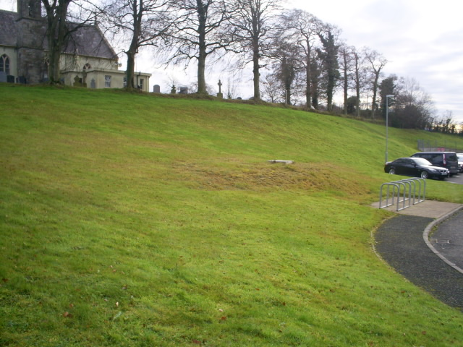
WHEN | We can Plant Trees between October and March. We will have to control weeds around them in the Spring and early Summer.

WHAT | WHERE
10. Hedgerow Planting | At the Treeline in front of the Old Church
We propose to plant hedgerow plants (Hawthorn and Blackthorn) along the treeline in front of the old church. These will replace some of the vegetation lost here as well as providing good cover for birds along this boundary.

WHEN | We can Plant Hedgerow between October and March

OTHER BIODIVERSITY PROJECTS FOR BALLYOISÍN

Some smaller-scale projects for the wider community are described by us here.

PROJECT | TYPE | DETAILS
A | BIRD FEEDERS: | We will purchase a number of birdfeeders in September and commit to keeping these well-filled throughout the year. We will have seed, peanut and fat-ball feeders. We can do some science experiments with these. For example, we can find out the best places for birds to find them and see which species of birds like which kinds of bird food. We can share our results with the National Biodiversity Data Centre.
B | COMMUNITY COMPOSTER: | It would be great to have a community composter for the village. There is space for this at the top of the Oisín Brian Estate. We will research this (Monaghan County Council will help us) and ask the residents of the village if they would like to undertake this project with us.
C | BUG HOTEL: | We will repair and refill our school’s Bug Hotel. This will mean making and keeping it full with both moist and dry areas and having a variety of sizes and shapes of holes for insects.
D | A BIG SIGN: | Our school and village should have a sign that tells visitors how committed to Biodiversity we are in Ballyoisin. We might ask a Mens’ Shed group or some local residents to help us with making this sign.

