Knockconan N.S. Green Schools Action Plan
Global Citizenship – Litter & Waste 2020 – 2022
Here is our action plan – actions we will be taking, when we will do them, what they will be and who will be taking the lead on them.
This is a living document, it was first devised in June 2020 after our last Green Flag was awarded for Biodiversity) and it has been added to over time.
Over the two years we have attempted to include actions under each theme we have covered so far as well as Litter & Waste ie energy, water, biodiversity and travel.
Covid measures have, of course had an effect on the activities of the Green Schools Committtee and particularly on meetings.
When? | What? | Who?
Citizenship 2020  October 2020 | Do Environmental review  Set up new committee  Update Green Schools display board  Committee leader to create presentation on the meaning of Global Citizenship and present to classes | Classes from 2nd – 6th
Global Citizenship 2020 | 4th Bluestar Award | All classes led by Mrs Donnelly’s room
Global Citizenship 2021  December 2021 | 5th Bluestar Award  Christmas Shoebox Appeal | All classes led by Mrs Donnelly’s room
School Grounds  2020, 2021 | Set up new seating areas outdoors with six large picnic benches capable of seating 24 socially distanced. Outdoor whiteboard also installed to facilitate outdoor learning.  All classes to use as often as possible, weather permitting. | All classes
School Grounds  Litter survey  2020, 2021  August 2020  May 2021  From Sept 2021  March 2022 | Litter on school grounds monitored by simple visual survey.  Litter tends to be to front of the building and in the carpark.  Litter free school – clear, simple antilitter policy means no lunches, food etc are allowed outside at any time.  Litter is generated by other users of the building.  Litter pickers used on Mondays to deal with any litter.  Litter bins were removed in summer 2020 as we felt they were attracting litter and wasps. Litter reduced after their removal.  Notices put up to remind people that dogs are not allowed on the grounds  Picker Pals – Miss Keenan’s class (2nd and 3rd) each child taking turns to take the picker pals kit home and do a litter-pick.  Litter pick of Ballyoisin area planned for 16th March | All classes
Energy  2020  March 2022 | “Switch it off” signs in place at light switches and whiteboards as reminders.  Low energy bulbs in place  Computers turned off when not in use  Members of Green School Committee to do spot checks in each classroom at break time on whatever day they choose. This will involve checking that doors are closed, lights switched off no taps running. They will update each teacher on results.  Energy champion poster activity – Rang 5 (pupils create a poster encouraging the saving of energy in the classroom or at home) | Committee  Bubble system means no visiting classrooms  Committee to ensure reminders at light switches etc
Healthy Living  2021  December 2021 and continuing | Healthy Eating Policy in place for several years – teachers monitor adherence to policy  Daily Mile Flag awarded  Began Work on Active Schools Flag Activities – soccer, volleyball, gymnastics, daily walk, athletics | Mrs. Donnelly’s room leading the Daily Mile 2020/2021  Mr. whites room leading 2021/2022
2020 (and previous years 2018 and 2019)  Ongoing  Ongoing  Ongoing  2020 (discontnued due to lack of space ref Covid measures)  Cut the rubbish campaign  Noted | - Clothes Collection Parents Association (fundraiser)  - Clothes Bank near school  - Classroom litter bins for segregation of waste into general waste for landfill and recyclable waste  - Re-use of water bottles encouraged  - Old uniforms donated by parents  - Compost bin  - Recycling bins for batteries, printer cartridges, phones and stamps  Cleaner tells us that extra bags are needed to deal with the amount of paper towel rubbish – clearly children pulling out extra paper towels & binning them – need for a “Just use one!” campaign | Parents Association  Committee to do just use one posters
Marine / Water  2021  2020  2022 | Catchment Care Project – schools project entitled “Little Ripples” involving education on monitoring water quality in local rivers and streams and learning about life in our waterways –  School pond and garden installed at front of school  Sliabh Beagh Project to follow on from this.  Self-stopping taps in all sinks and water-saving flush mechanisms on all toilets  Posters to remind people to turn off taps at other sinks to save water  “The Sea Starts Here” stencil for drains on the playground (to be sprayed on later in the year when conditions allow) | Mr Buckleys room )3rd/4th/5th classes) ;eading this project.  Waiting for drier weather before use of stencil.
Biodiversity | Catchment Care project – as above  School Pond and Pollinator garden installed  Pollinator friendly bulb planting at front of school  Nature walks – Junior classes  Biodiversity Visit/Walk on school grounds funded by Heritage Council  Willow dome constructed in sensory garden area (under development)  Bird tables outdoors and in atrium inside the building.  Insect hotels to rear of building  10 native trees planted March 2022 (sponsored by ABP)  Wildflower seeds supplied by Supervalu to be sown indoors to plant out later, also vegetables and lettuce  Mr Whites room doing Incredible Edibles | The Green Schools Committee also acts as the local TidyTowns committee.
2021 and ongoing | Create page on school web site for Green Schools Global citizenship and update with actions  Add useful links to web page including  - The World’s Largest Lesson: http://worldslargestlesson.globalgoals.org  - DevelopmentEducation.ie: www.DevelopmentEducation.ie  - Amnesty International Ireland: www.amnesty.ie  - UNICEF: www.unicef.ie  - Irish Aid: www.irishaid.gov.ie  - Fairtrade Mark Ireland: www.fairtrade.ie  - WorldWise Global Schools: www.worldwiseschools.ie  - Global Goals for Sustainable Development: http://www.globalgoals.org  - Low Carbon Diet: www.eatlowcarbon.org  Since the beginning of Covid our newsletters have been distributed by email and through the school web site only ie no printing and no paper wasted.  Shorter messages to parents are done through textaparent. | Principal
March 2022 | Redo GC survey  All classes to strive to reduce the amount of waste we are producing in our classroom bins. Looking at  - Ways to reduce waste in the classroom:  - no packaging in lunch boxes  - go easy on the paper towels  - use both sides of a piece of paper (put a half used page into the reusable box)  - use the compost bin  - recycle paper, plastic, cardboard
March 2022 | Plastic Free March  The Green Schools Committee has decided to focus on our use of single use plastic packaging. We will focus our attention on reducing the amount of plastic wrapping we use in the school community.  We will record the number of plastic free lunches in the room. Our Green Recycling Ambassadors will survey our bins to notice and measure improvements we make.  We will encouraging plastic free shopping and ask every family to sign up to “Get rid of plastic!
2022 | Develop a Sustainability Policy for the school  Completed and ratified 24 1 22 | Principal,  Board of Management,  School community
2022 | Curriculum (Literacy ) Wordle Art  Senior classes will create Wordle Art using words based on the themes of Environment, Litter & Waste, Water, Energy, Biodiversity, Travel and Global Citizenship.  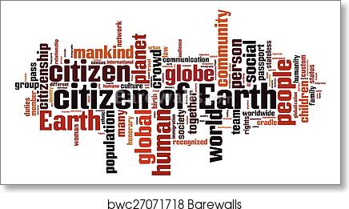 | 3rd – 5th classes
February 2022 | Curriculum (Visual Art) Habitat Diorama  Rang 5 & 6 make dioramas based on the theme of habitats and discussed the advantages and disadvantages of living in each type of habitat and how animals and people have to adapt.  https://www.generationgenius.com/activities/habitats-activity-for-kids/  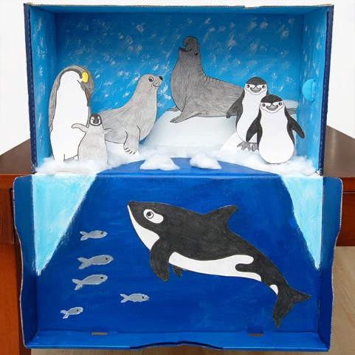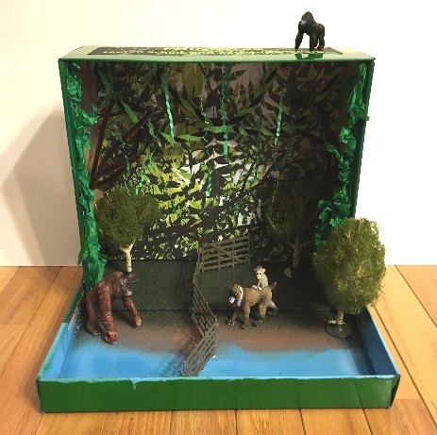
January 2022 | Climate Change work – Mrs Mc Ginn ( Junior & Senior infants) room focusing on the life of the penguin and “adopt a penguin” through the  World Wildlife Fund (WWF)
March 2022 | Curriculum =  PowerPoint Presentations on  Dail Eireann / Govt of Ireland  Climate Change  Sustainability  Earth Day  Life on the Planet  Quizzes - https://greenschoolsireland.org/greenschools-quizzes/  General Quiz & SDG 3. 10, 11, 13

