Townland – Moy, Emyvale
by Noah– April 2020

My townland is Moy, Emyvale.
The townland of Moy (or Moybridge as it is sometimes referred to) is in the parish of Errigal Truagh and it is the most northerly townland of Co. Monaghan with the river Blackwater flowing through it which acts as the border between Co. Monaghan and Co. Tyrone in Northern Ireland. The Slieve Beagh mountains, more popularly known as ‘Bragan Mountains’ can also be seen in the distance.

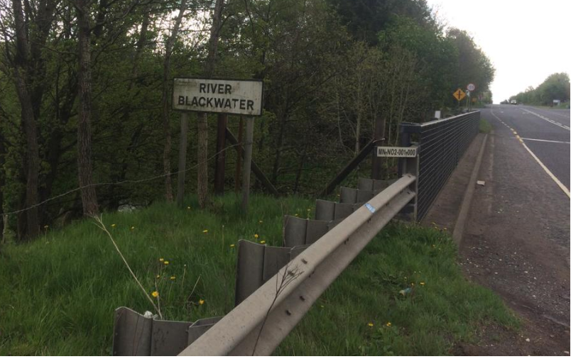
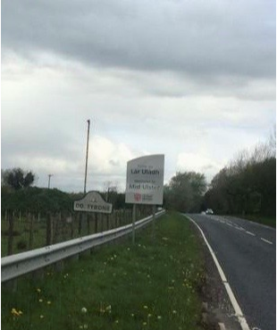

Errigal Truagh Medieval Church & Graveyard
At the end of my road is Errigal Truagh medieval church and graveyard. It is one of the most ancient religious sites in Ulster. It is believed to have been a site of ancient worship as far back as early Christian times.

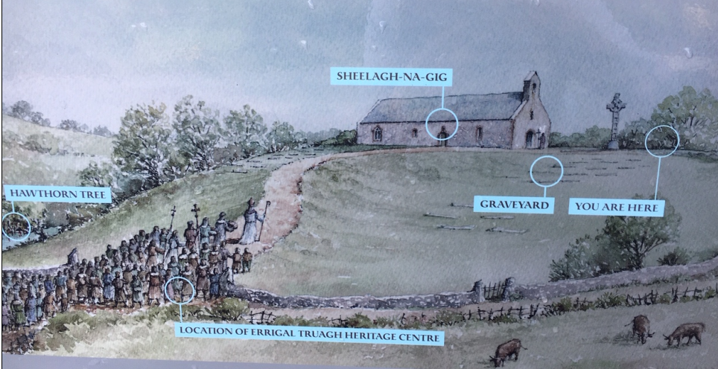

The graveyard was used for burials into the present century, but the church next to it was dismantled in 1835. The church is dedicated to St. Mellan.

CHURCH:
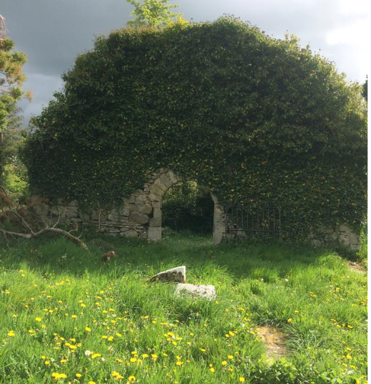

GRAVEYARD:
The graveyard has one of the most important collections of headstones and enclosures in Ireland. During the 18th century it became fashionable to decorate headstones in an ornate, stylised way. At Errigal, a very distinctive Ulster style can be clearly identified. Many of the headstones feature the five mortality symbols: skulls, long bones, coffins, bells and hourglasses. During the 18th century mortality symbols began to be replaced by cherubs, representing the soul of the deceased on their way to heaven. Other figures, standing or kneeling in prayer, and depictions of Adam and Eve either side of the Tree of Life sometimes accompany them.

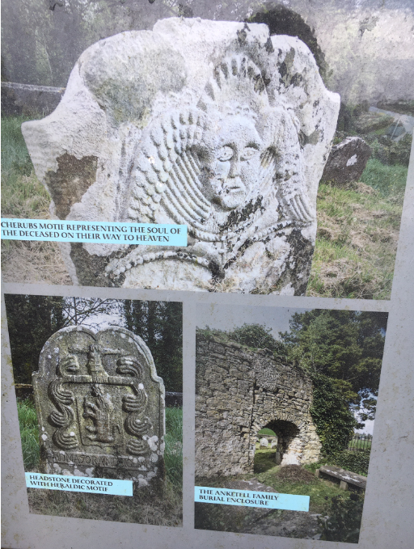

FAMILY NAMES:

Three families, reflecting the wealth of local landowners of the time, are particularly well represented. Both the Anketell and the Singleton graves area in separate railed off areas. The most significant though is the group of figurative gravetsones belonging to the Mckenna family near the east gable. Several elderly priests’ graves with decorative gravestones near the west gable are also worth seeing.
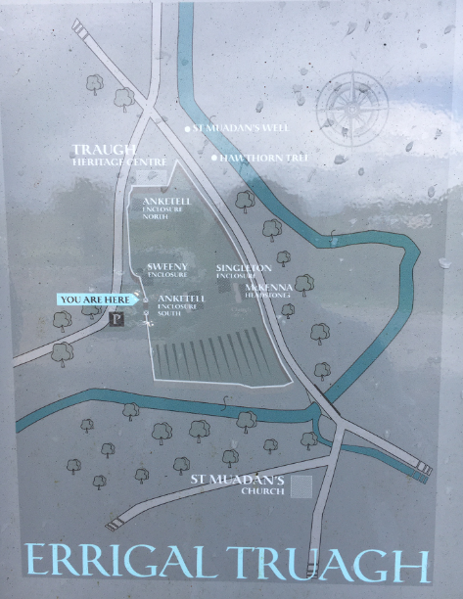

ERRICAL TRUAGH HERITAGE CENTER:
There is an Old Schoolhouse that has been turned into a heritage centre and there is a plaque commemorating the McKenna family on it dated July 1st 2000.
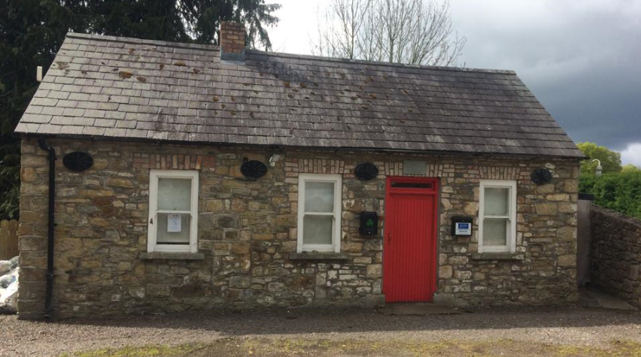

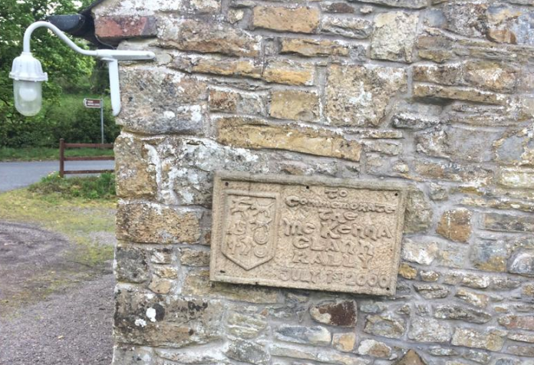
HOLY WELL:
There is also holy well that attracted generations of pilgrims until the nineteenth century, people who were hoping for cures. People can still visit the well to this day. People might come to the holy well to for holy water to bring to the sick or elderly.

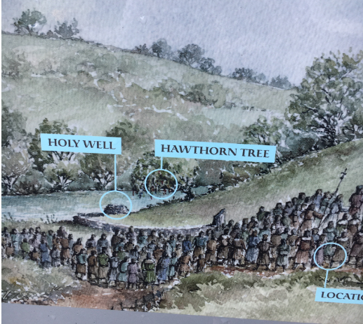
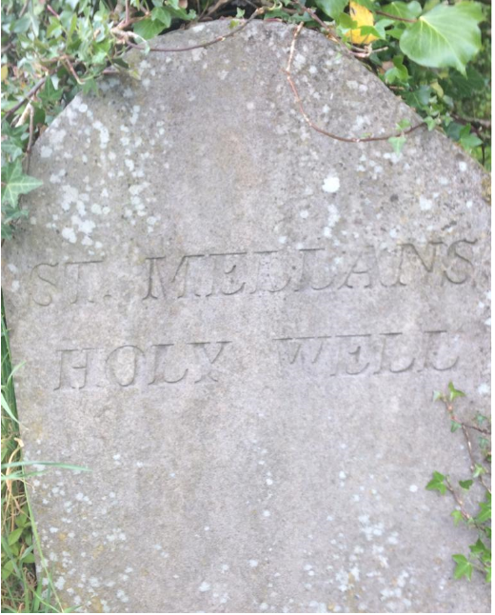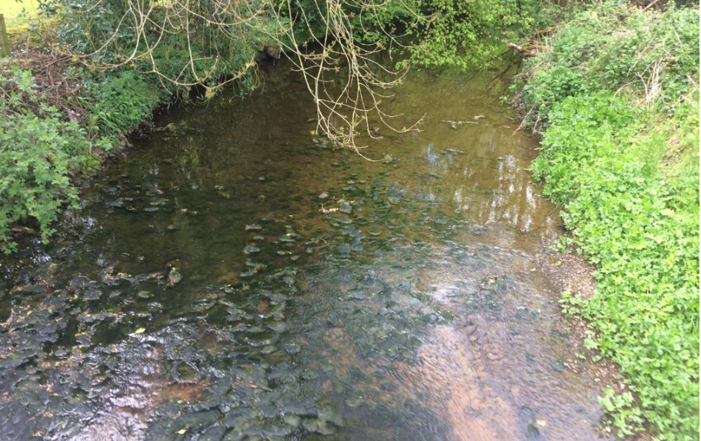

PRESENT CHURCH OF IRELAND PARISH CHURCH:

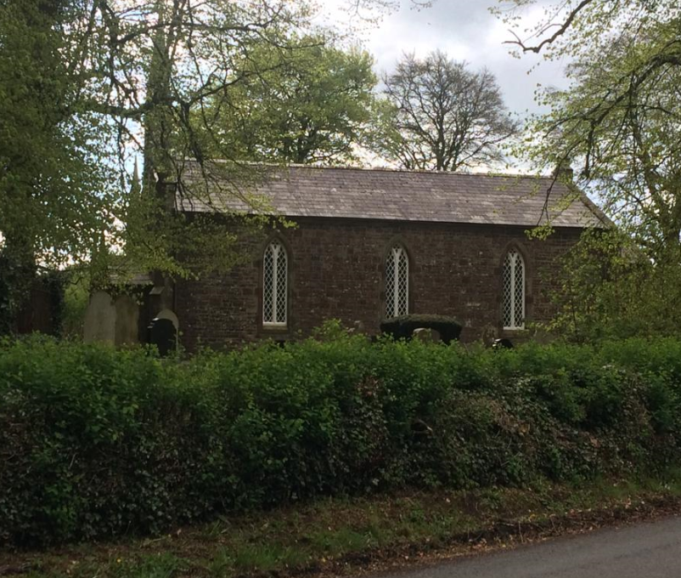
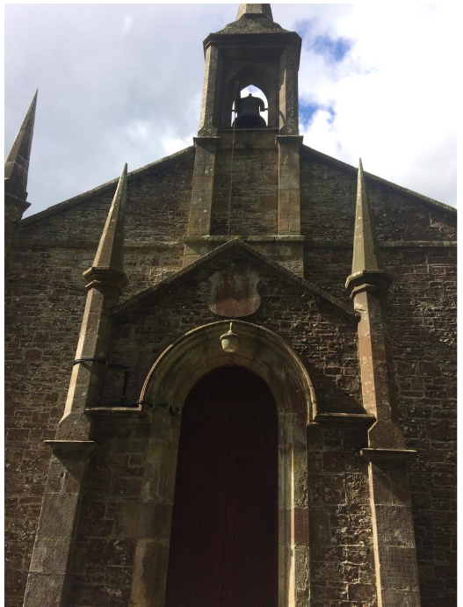

ENVIRONMENT: Luckily there is very little pollution/litter in my townland. On my walk with my family, we just came across one coffee cup that had been left on the side of the road. The rest of the roadway was free of litter.
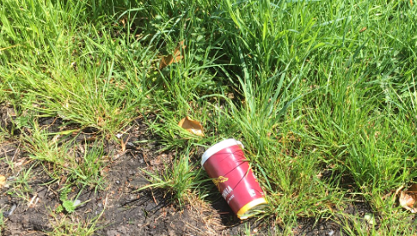

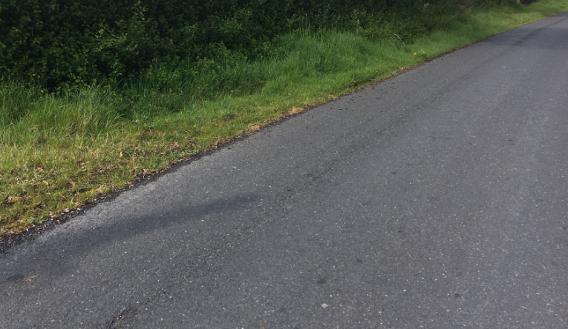

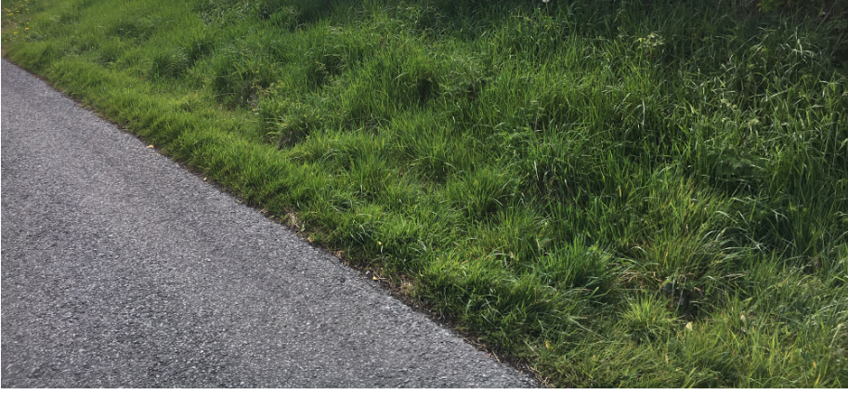
FLOWERS:
The only flowers on the roadside in my townland are the ones attached below:
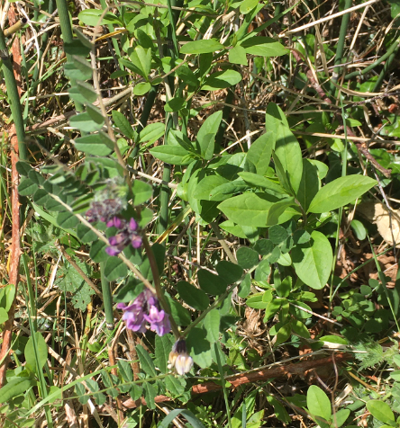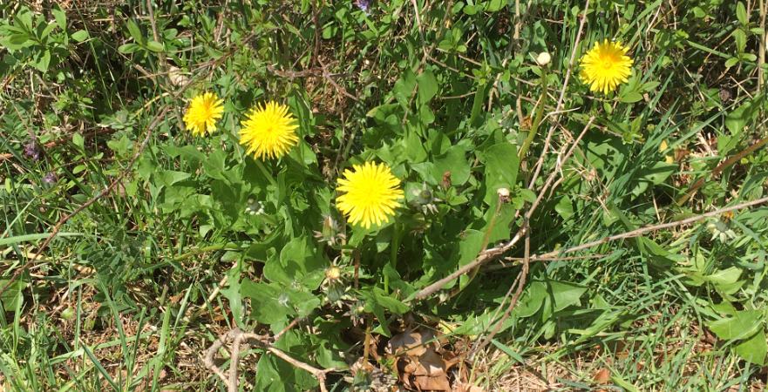
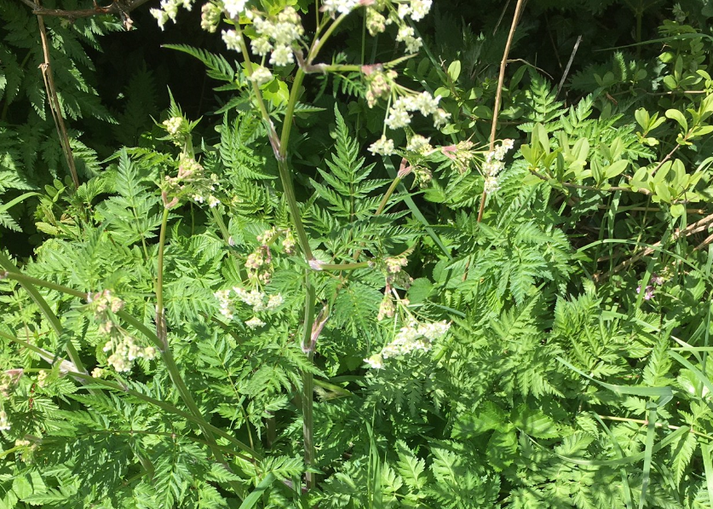

CONCLUSION:
I am very lucky to live in a townland that has such a rich history and it is very interesting reading the names and dates on the headstones in the graveyard because they are so old. Luckily there is not much litter or pollution spoiling the area either and our neighbours are very good at keeping the area clean and free from litter.

