Cavan Monaghan Science Week – Bridges project – Knockconan NS

Winning Bridges

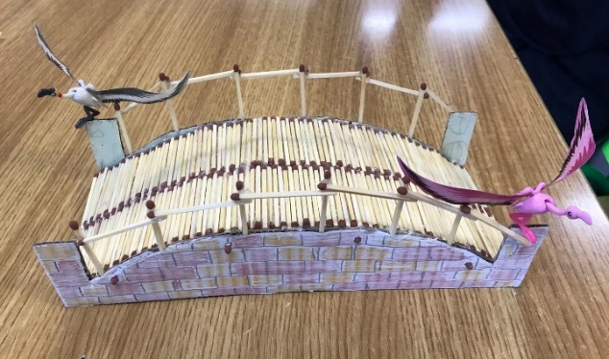

1st

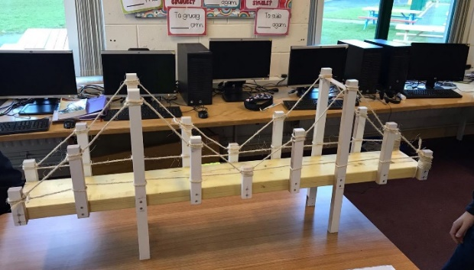

2nd

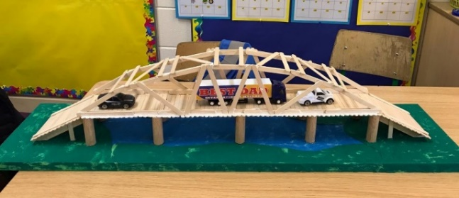3rd

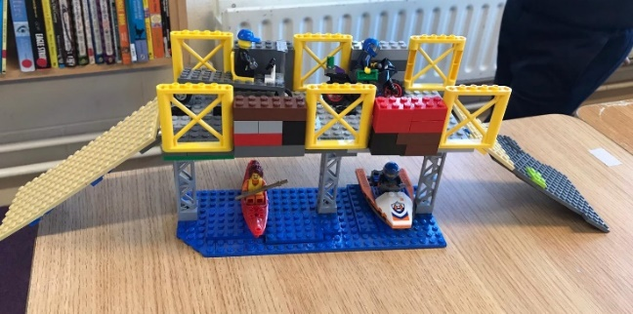4th

|  |  |  |
| --- | --- | --- |
| **Place** | **Bridge**  **No:** | **Comments and marks out of 60** |
| *1st* | 12 | Judges liked the use of matchsticks and the colour and shape of the bridge. The addition of the birds looked superb. Judges appreciated the time taken in lining up the matchsticks to make the bridge surface. Pleasant design. **52/60** |
| *2nd* | 9 | Judges were impressed with the workmanship and construction of this bridge. It was a great structure. **51/60** |
| *3rd* | 20 | Judges liked the design of this bridge and the use of vehicles on the bridge. It was well presented. **50/60** |
| *4th* | 11 | Judges liked the design of this bridge and thought including the water and canoeists to be a good element. **48/60** |
| *Joint 5th* | 3 | Judges liked the design and use of decorative features. It was a well put together bridge. **43/60** |
| *Joint 5th* | 15 | Judges were impressed with the simple structure and strength of this bridge. Very well made. **43/60** |
| *6* | 6 | Judges liked the structure of the bridge and the craftmanship in the design. It looks very strong and durable. **42/60** |
| *Joint 7th* | 4 | Judges liked the craftmanship and originality of the design. It looked like a strong and durable bridge. **41/60** |
| *Joint 7th* | 14 | Judges like the way the materials chosen were used. It was a very original, well thought out design. **41/60** |
| *Joint 7th* | 24 | Well designed, strong bridge with good use of the materials chosen. **41/60** |
| *8* | 19 | Excellent design and construction – and Judges scored highly for originality. **40/60** |
| *Joint 9th* | 5 | Unique design – vehicles added to the creativity of the bridge. **39/60** |
| *Joint 9th* | 23 | Good use of materials – totally original design and decorative features made this bridge stand out. **39/60** |
| *10* | 1 | Good structure – great attention to detail and well-crafted bridge. **38/60** |
| *11* | 22 | Good use of materials – great finishing touches with road and care detail – great original design. **37/60** |
| *12* | 16 | Good use of Lego – very bright and colourful design. Nice use of additional features of people. **36/60** |
| *Joint 13th* | 2 | Good strong, durable bridge. Good use of materials to create effective design. **35/60** |
| *Joint 13th* | 17 | Unique, original design using minimal materials well. **35/60** |
| *Joint 14th* | 10 | Good colourful bridge, nice use of materials. Well presented. **34/60** |
| *Joint 14th* | 13 | Original design with good use of decorative features. Well crafted. **34/60** |
| *Joint 14th* | 18 | Judges appreciated the minimal design and good use of materials. Well crafted, original bridge. **34/60** |
| *15* | 21 | A unique bridge with good use of materials and Judges enjoyed the nice application of decorative design. **33/60** |
| *Joint 16th* | 7 | Minimal bridge, well-constructed with good craftsmanship. **32/60** |
| *Joint 16th* | 8 | Original bridge with good use of materials. Minimal but effective design. **32/60** |

|  |  |
| --- | --- |
| **Criteria** | **Marks out of 5** |
| Efficient use of materials | 3 4 |
| Elegance of design | 4 4 |
| Additional / decorative features | 2 3 |
| Durability | 2 2 |
| Craftsmanship | 4 4 |
| Originality | 3 3 |
| **Total: 38** | **18 20** |

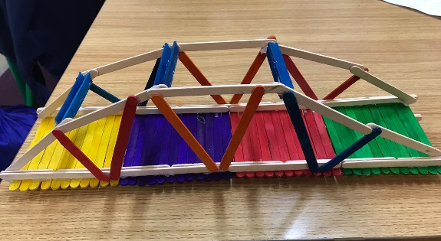

1

|  |  |
| --- | --- |
| **Criteria** | **Marks out of 5** |
| Efficient use of materials | 3 3 |
| Elegance of design | 2 2 |
| Additional / decorative features | 3 2 |
| Durability | 5 5 |
| Craftsmanship | 3 3 |
| Originality | 2 2 |
| **Total: 35** | **18 17** |

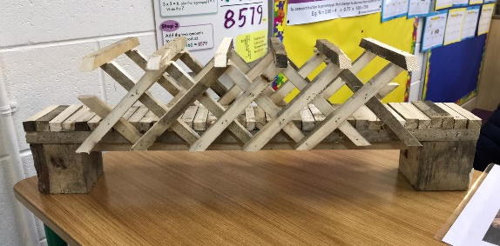

2

|  |  |
| --- | --- |
| **Criteria** | **Marks out of 5** |
| Efficient use of materials | 3 4 |
| Elegance of design | 3 3 |
| Additional / decorative features | 5 3 |
| Durability | 2 2 |
| Craftsmanship | 4 4 |
| Originality | 5 5 |
| **Total: 43** | **22 21** |

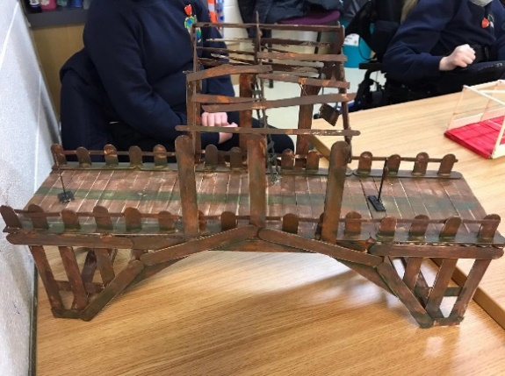

3

|  |  |
| --- | --- |
| **Criteria** | **Marks out of 5** |
| Efficient use of materials | 2 3 |
| Elegance of design | 2 3 |
| Additional / decorative features | 3 2 |
| Durability | 5 4 |
| Craftsmanship | 4 4 |
| Originality | 4 5 |
| **Total: 41** | **20 21** |

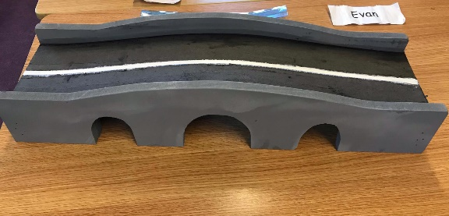

4

|  |  |
| --- | --- |
| **Criteria** | **Marks out of 5** |
| Efficient use of materials | 3 2 |
| Elegance of design | 2 2 |
| Additional / decorative features | 5 5 |
| Durability | 3 4 |
| Craftsmanship | 3 3 |
| Originality | 4 3 |
| **Total: 39** | **20 19** |

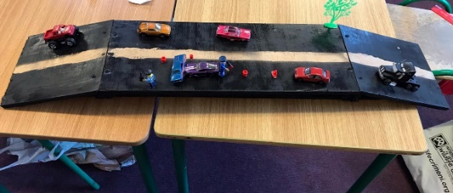

5

|  |  |
| --- | --- |
| **Criteria** | **Marks out of 5** |
| Efficient use of materials | 3 3 |
| Elegance of design | 3 4 |
| Additional / decorative features | 3 3 |
| Durability | 4 4 |
| Craftsmanship | 4 4 |
| Originality | 3 3 |
| **Total: 42** | **21 21** |

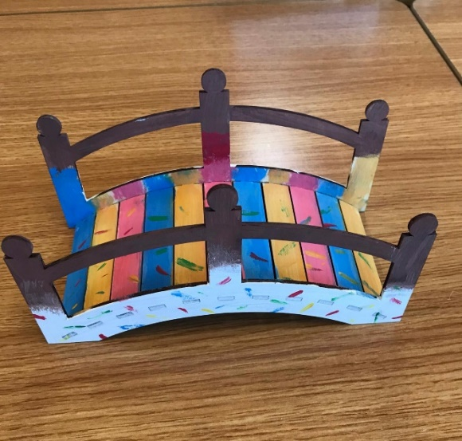

6

|  |  |
| --- | --- |
| **Criteria** | **Marks out of 5** |
| Efficient use of materials | 3 2 |
| Elegance of design | 3 2 |
| Additional / decorative features | 1 1 |
| Durability | 4 3 |
| Craftsmanship | 3 3 |
| Originality | 4 3 |
| **Total: 32** | **18 14** |

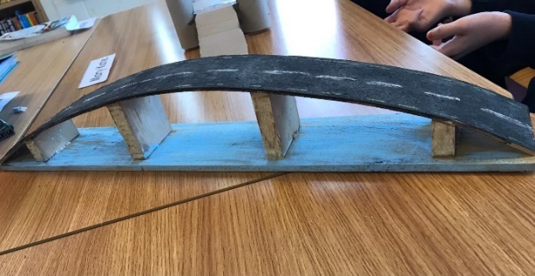

7

|  |  |
| --- | --- |
| **Criteria** | **Marks out of 5** |
| Efficient use of materials | 3 2 |
| Elegance of design | 2 2 |
| Additional / decorative features | 3 3 |
| Durability | 2 2 |
| Craftsmanship | 3 2 |
| Originality | 5 3 |
| **Total: 32** | **18 14** |

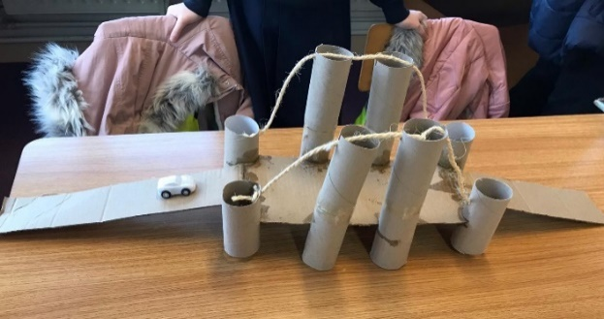

8

|  |  |
| --- | --- |
| **Criteria** | **Marks out of 5** |
| Efficient use of materials | 4 5 |
| Elegance of design | 4 5 |
| Additional / decorative features | 4 4 |
| Durability | 3 4 |
| Craftsmanship | 4 5 |
| Originality | 4 5 |
| **Total: 51** | **23 28** |



9

|  |  |
| --- | --- |
| **Criteria** | **Marks out of 5** |
| Efficient use of materials | 4 3 |
| Elegance of design | 3 3 |
| Additional / decorative features | 2 2 |
| Durability | 1 2 |
| Craftsmanship | 3 3 |
| Originality | 5 3 |
| **Total: 34** | **18 16** |

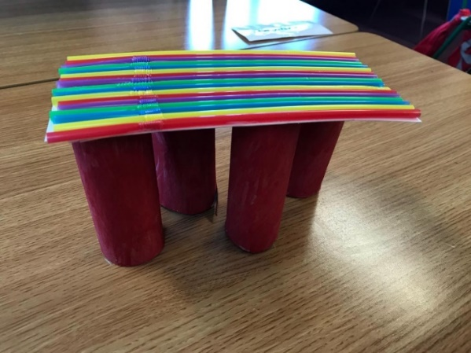

10

|  |  |
| --- | --- |
| **Criteria** | **Marks out of 5** |
| Efficient use of materials | 4 4 |
| Elegance of design | 3 5 |
| Additional / decorative features | 4 5 |
| Durability | 3 5 |
| Craftsmanship | 4 4 |
| Originality | 3 4 |
| **Total: 48** | **21 27** |



11

|  |  |
| --- | --- |
| **Criteria** | **Marks out of 5** |
| Efficient use of materials | 4 5 |
| Elegance of design | 5 5 |
| Additional / decorative features | 4 4 |
| Durability | 2 3 |
| Craftsmanship | 5 5 |
| Originality | 5 5 |
| **Total: 52** | **25 27** |



12

|  |  |
| --- | --- |
| **Criteria** | **Marks out of 5** |
| Efficient use of materials | 4 3 |
| Elegance of design | 3 3 |
| Additional / decorative features | 2 2 |
| Durability | 2 2 |
| Craftsmanship | 3 3 |
| Originality | 4 3 |
| **Total: 34** | **18 16** |

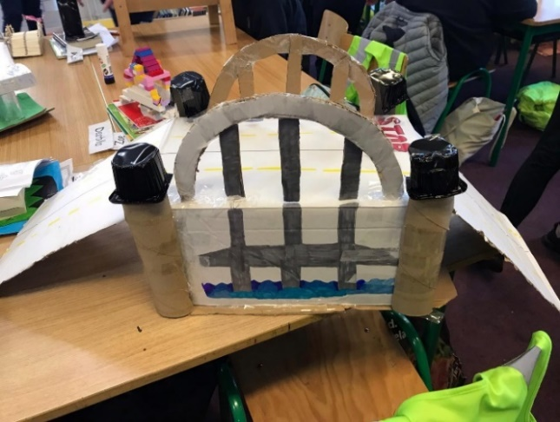

13

|  |  |
| --- | --- |
| **Criteria** | **Marks out of 5** |
| Efficient use of materials | 4 4 |
| Elegance of design | 4 4 |
| Additional / decorative features | 3 3 |
| Durability | 2 3 |
| Craftsmanship | 3 3 |
| Originality | 4 4 |
| **Total: 41** | **20 21** |

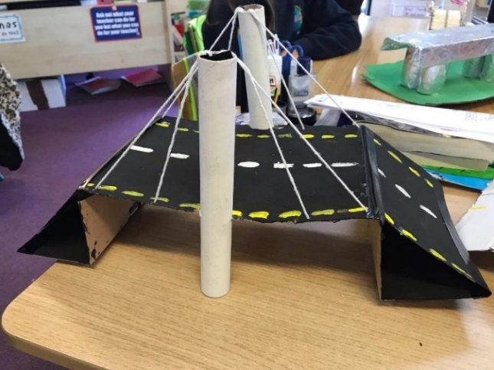

14

|  |  |
| --- | --- |
| **Criteria** | **Marks out of 5** |
| Efficient use of materials | 4 4 |
| Elegance of design | 2 3 |
| Additional / decorative features | 2 2 |
| Durability | 5 5 |
| Craftsmanship | 4 4 |
| Originality | 4 4 |
| **Total: 43** | **21 22** |

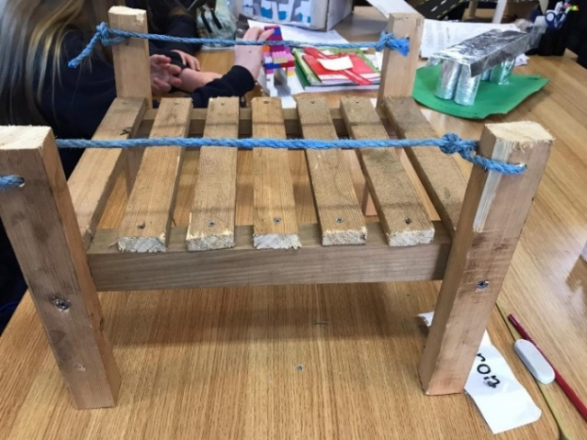

15

|  |  |
| --- | --- |
| **Criteria** | **Marks out of 5** |
| Efficient use of materials | 4 4 |
| Elegance of design | 3 3 |
| Additional / decorative features | 3 3 |
| Durability | 2 2 |
| Craftsmanship | 3 3 |
| Originality | 3 3 |
| **Total: 36** | **18 18** |

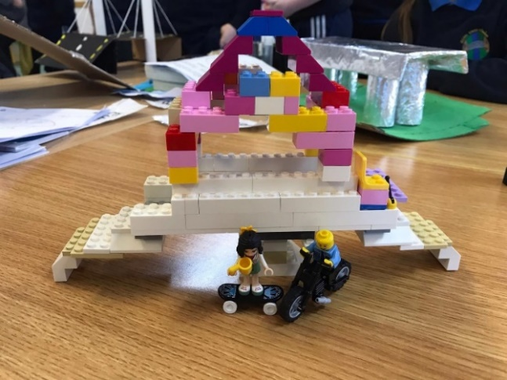

16

|  |  |
| --- | --- |
| **Criteria** | **Marks out of 5** |
| Efficient use of materials | 3 3 |
| Elegance of design | 2 2 |
| Additional / decorative features | 3 2 |
| Durability | 3 3 |
| Craftsmanship | 3 3 |
| Originality | 4 4 |
| **Total: 35** | **18 17** |

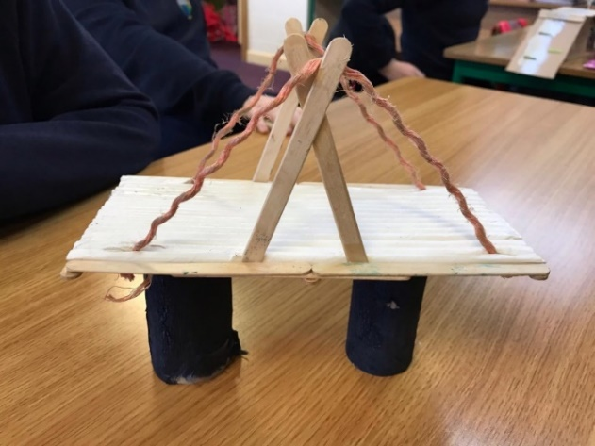

17

|  |  |
| --- | --- |
| **Criteria** | **Marks out of 5** |
| Efficient use of materials | 3 3 |
| Elegance of design | 3 3 |
| Additional / decorative features | 2 2 |
| Durability | 2 2 |
| Craftsmanship | 4 3 |
| Originality | 4 3 |
| **Total: 34** | **18 16** |

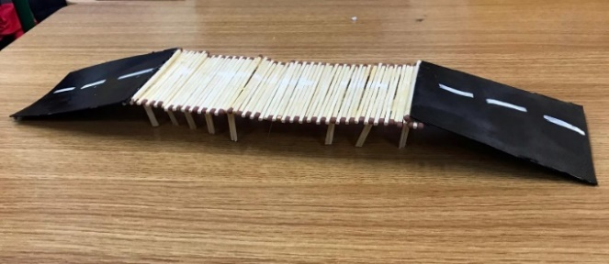

18

|  |  |
| --- | --- |
| **Criteria** | **Marks out of 5** |
| Efficient use of materials | 5 4 |
| Elegance of design | 3 3 |
| Additional / decorative features | 2 3 |
| Durability | 1 2 |
| Craftsmanship | 4 4 |
| Originality | 5 4 |
| **Total: 40** | **20 20** |

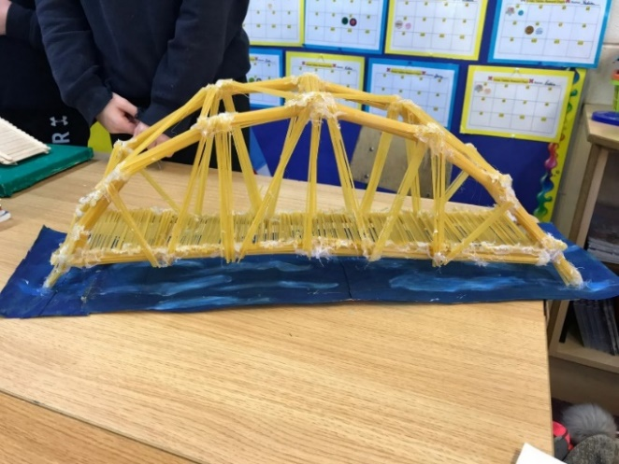

19

|  |  |
| --- | --- |
| **Criteria** | **Marks out of 5** |
| Efficient use of materials | 4 5 |
| Elegance of design | 4 5 |
| Additional / decorative features | 5 5 |
| Durability | 3 4 |
| Craftsmanship | 5 5 |
| Originality | 5 5 |
| **Total: 50** | **21 29** |



20

|  |  |
| --- | --- |
| **Criteria** | **Marks out of 5** |
| Efficient use of materials | 4 3 |
| Elegance of design | 2 2 |
| Additional / decorative features | 3 2 |
| Durability | 2 2 |
| Craftsmanship | 3 3 |
| Originality | 4 3 |
| **Total: 33** | **18 15** |

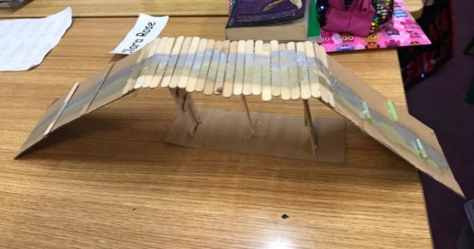

21

|  |  |
| --- | --- |
| **Criteria** | **Marks out of 5** |
| Efficient use of materials | 3 3 |
| Elegance of design | 3 3 |
| Additional / decorative features | 3 3 |
| Durability | 2 2 |
| Craftsmanship | 4 3 |
| Originality | 4 3 |
| **Total: 37** | **20 17** |

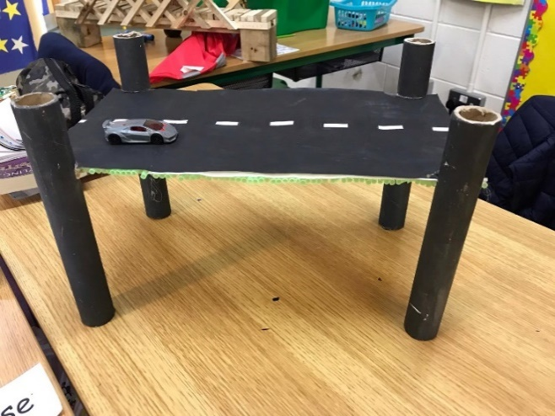

22

|  |  |
| --- | --- |
| Criteria | Marks out of 5 |
| Efficient use of materials | 3 3 |
| Elegance of design | 3 3 |
| Additional / decorative features | 3 3 |
| Durability | 3 3 |
| Craftsmanship | 3 3 |
| Originality | 5 4 |
| **Total: 39** | **20 19** |

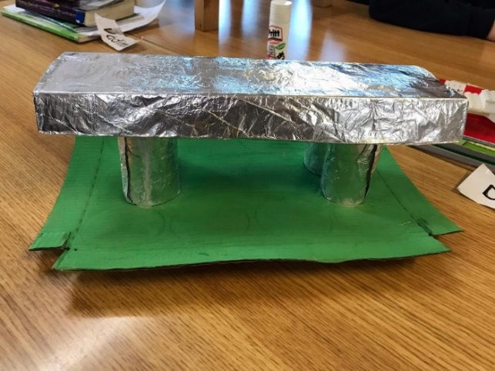

23

|  |  |
| --- | --- |
| **Criteria** | **Marks out of 5** |
| Efficient use of materials | 3 4 |
| Elegance of design | 3 3 |
| Additional / decorative features | 3 3 |
| Durability | 3 3 |
| Craftsmanship | 4 4 |
| Originality | 4 4 |
| **Total: 41** | **20 21** |

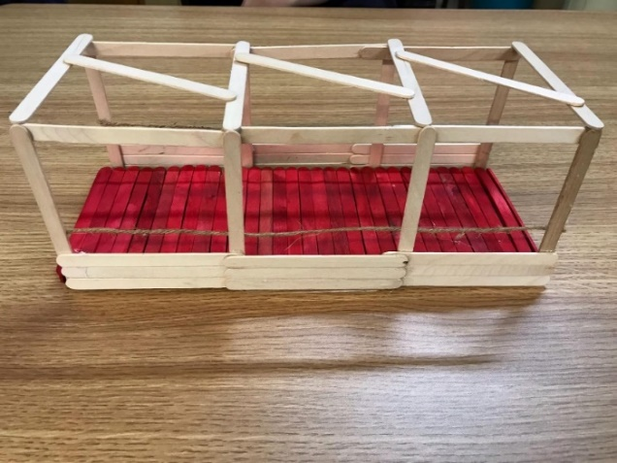

24